**Project Documentation**:

**Project Title:**InsightStream Navigate The News Landscape

1.**Introduction**:

* Project Title: InsightStream: Navigate The News Landscape
* Team ID: (NM2025TMID35089)
* Team Leader: Ayesha Sulaiha S

(ayeshasulaiha1017@gmail.com**)**

* **Team Members**:

1. Abinaya S

(abinayaabi0385@gmail.com)

2.Keerthika S

(keerthisanmugam67@gmail.com)

3. Swetha V

(swethavishwanathan42@gmail.com)

4. Rishiyana Begam A

(rishiyanabegam8@gmail.com)

**2**.**Project Overview**:

**Purpose:**

InsightStream is a web-based news aggregation and recommendation platform.

It allows users to explore trending news,filter by categories,save articles,and persionalise their News feed for a sreaminlined reading history

**Features:**

* Browse latest news by category (Politics, Tech, Sports, Entertainment, etc.)
* Search news by keywords
* Save favorite articles for later reading
* Personalized recommendations based on reading history
* Responsive, modern UI

**3.Architecture:**

* Frontend: React.js with Tailwind CSS / Bootstrap
* Backend: Node.js / Express (REST API)
* Database: MongoDB (for users, saved articles, preferences)
* External API: News API (for real-time news articles)

**4.Technologies Used:**

* React.js
* Node.js / Express
* MongoDB
* Tailwind CSS / Bootstrap
* News API
* Git & VS Code

**5.Installation Steps:**

#Clone the project

git clone <https://github.com/your-repo/InsightStream.git>

cd InsightStream

#Install dependencies

npm install

#Start the React frontend

npm run dev

In a separate terminal (backend):

cd server

npm install

npm start

Access at: <http://localhost:5173>

**6.Folder Structure:**

InsightStream/

■-- client/ # Frontend (React)

■ ■-- src/

■ ■-- assets/ # Images, icons

■ ■-- components/

■ ■-- pages/

■ ■-- App.jsx

■ ■-- main.jsx

■-- server/ # Backend (Node.js + Express)

■ ■-- routes/

■ ■-- models/

■ ■-- controllers/

■ ■-- server.js

■-- README.md

**7.Running the Application:**

* Frontend:

npm run dev

* Backend:

npm start

* Access: <http://localhost:5173>

**8.API Documentation:**

**Articles:**

* GET /api/articles → Get all articles
* GET /api/articles/:id → Get article by ID
* POST /api/articles/save → Save article
* DELETE /api/articles/:id → Delete saved article

**Users:**

* POST /api/users/register → Register new user
* POST /api/users/login → Login
* GET /api/users/:id → Get user details

**Recommendations:**

* GET /api/recommendations/:userId → Get personalized news feed

**9.Authentication:**

* Implemented using JWT (JSON Web Token)
* Passwords stored securely with hashing

**10.User Interface:**

* Landing Page (Trending News)
* Sidebar Navigation (Categories: Tech, Sports, etc.)
* Article Cards (title, image, description, source, save button)
* Personalized Feed (AI-driven recommendations)
* Saved Articles Page

**11.Testing:**

* Manual Testing: Verified news fetching, search, and article saving
* Tools: Postman, Chrome Dev Tools, MongoDB Compass

**12.Screenshots:**

* Homepage:

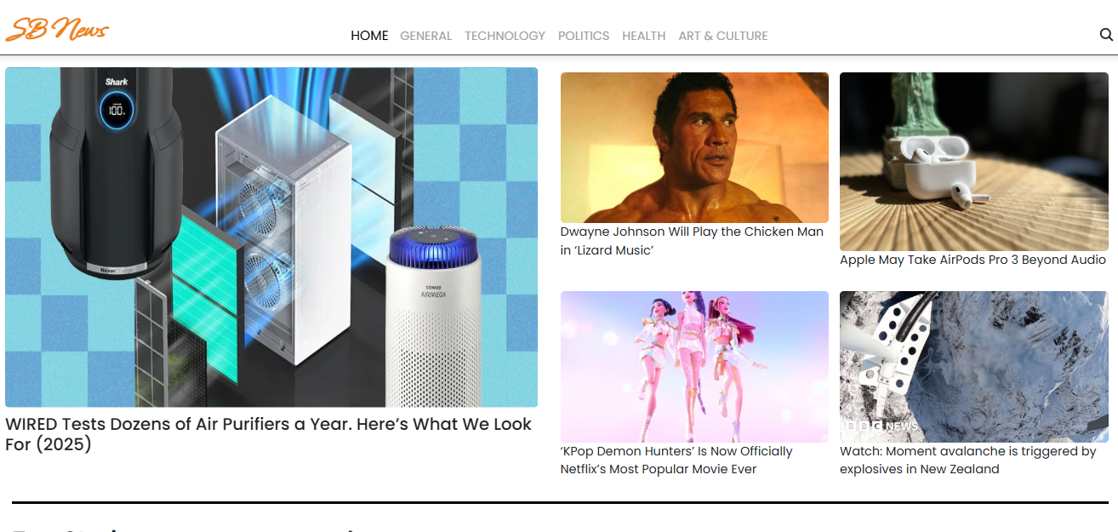

* General:

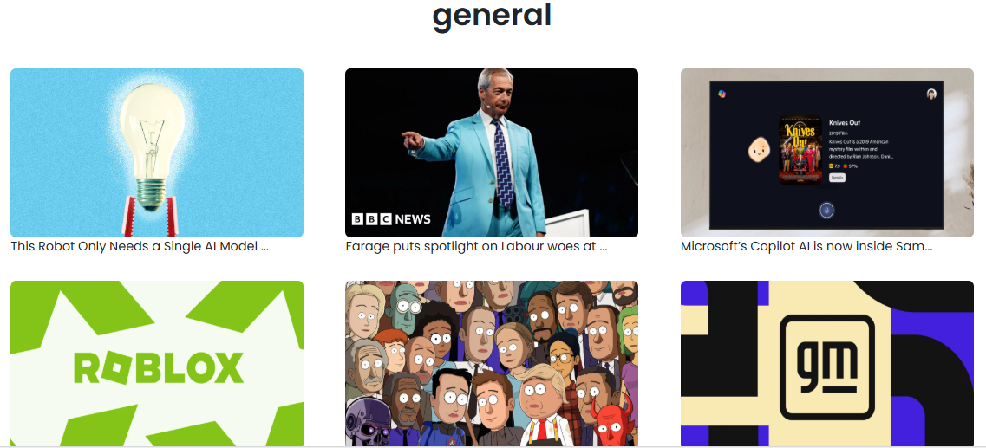

* Technology:

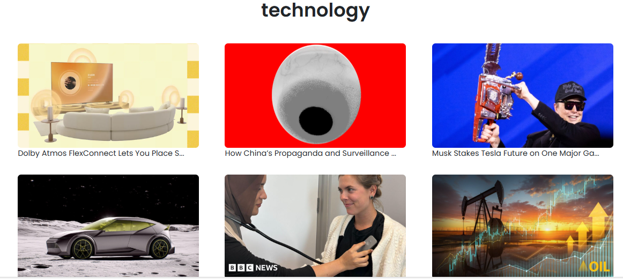

* Politics:

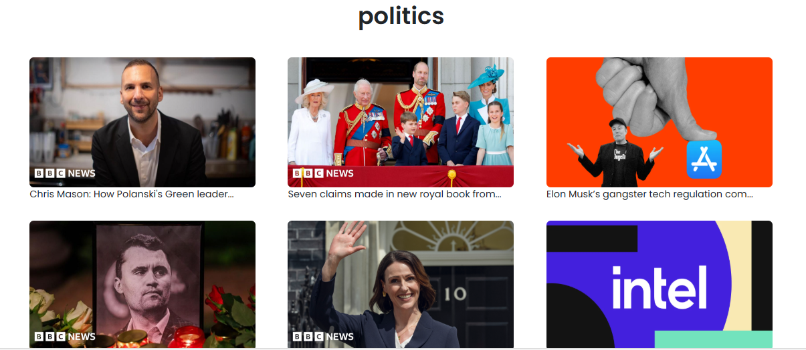

**13.Known Issues:**

* API request limits with free News API key
* Basic personalization model (not fully AI-driven yet)
* Saved articles only accessible online

**14.Future Enhancements:**

* Advanced AI-based recommendations (NLP sentiment analysis)
* Mobile App (React Native)
* Offline reading mode
* Multi-language news support
* Push notifications for breaking news